RESOLUTION NO.__________

RE: CERTIFICATE OF APPROPRIATENESS UNDER THE
PROVISIONS OF THE ACT OF THE PENNSYLVANIA
LEGISLATURE 1961, JUNE 13, P.L. 282 (53
SECTION 8004) AND BETHLEHEM ORDINANCE NO.
3952 AS AMENDED.

WHEREAS, it is proposed to install signs at 308 S New Street.

NOW, THEREFORE, BE IT RESOLVED by the Council of the City of Bethlehem that a Certificate of Appropriateness is hereby granted for the work.

Sponsored by: (s)

(s)

ADOPTED BY COUNCIL THIS DAY OF

(s)
President of Council

ATTEST:

(s)
City Clerk

HISTORIC CONSERVATION COMMISSION

CASE # 563– It is proposed to install signs at 308 S New Street
OWNER/APPLICANT: Dennis Benner / Heather Griffith

The Commission upon motion by Mr. Cornish seconded by Mr. Loush adopted the proposal that City Council issue a Certificate of Appropriateness for the proposed work described herein:
- The proposal to install signs at 308 S New Street was presented by Heather Griffith.
- A double-sided projecting sign approximately 36” wide x 39” high will be installed on the front façade. If possible, the sign will be hung on the left side of the storefront. If not, it will be hung on the right side of the storefront as originally proposed.
- The projecting sign will hang from a black metal scroll bracket and read “Wrap’d tight gourmet wraps & salads” with 308 on the bottom. The sign will have an off white background with brown lettering for “Wrap’d tight” and 308; and a green background with off white lettering for gourmet wraps & salads. The green will also form a border around the entire sign.
- A flat wall sign will be mounted on the façade above the storefront windows and will read the same as the projecting sign with the addition of “Delivery & Catering” with the phone number and a logo to the left. The colors will be the same as for the projecting sign.
- The fasteners for both signs must be mounted into mortar joints and not into the terra cotta, brick, or stone.
- The proposed motion was unanimously approved.

CU: cu
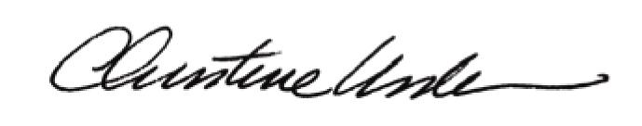

By:

Date of Meeting: August 17, 2015 Title: Historic Officer

